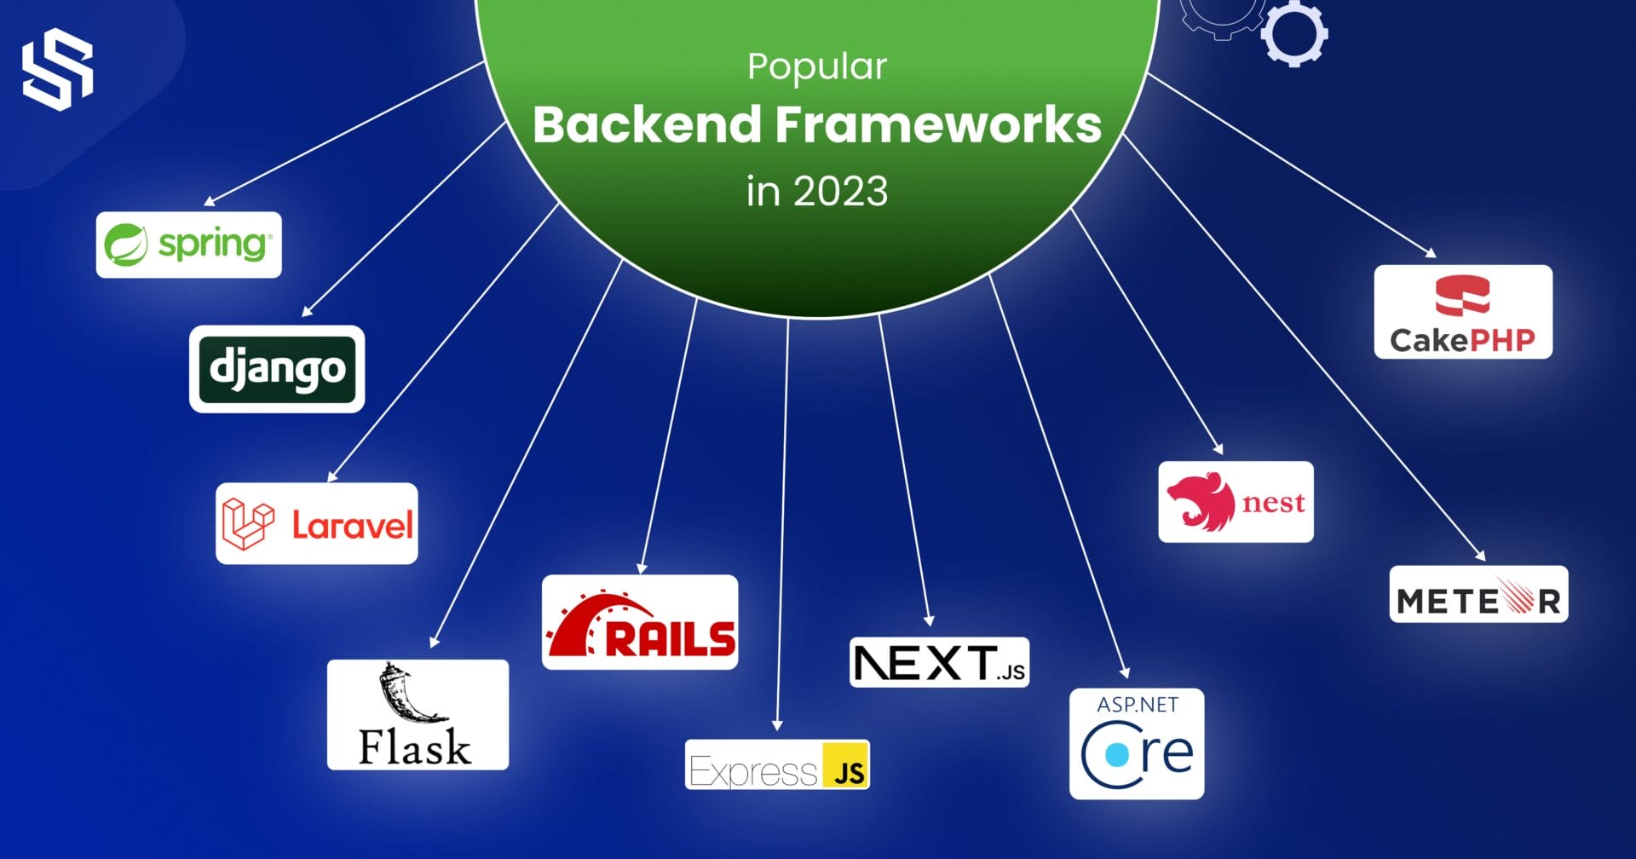

Client Side Vs Server Side
Front End Developer or Client Side
A front end developer designed every aspect of a web page, including the logo, search function, icons, general layout, and user interface. The style and appearance of the website are at the control of front end developers. Additionally, front end developers must guarantee that the website appears nice across all platforms (mobile phones, tablets, and computer). The responsive web design is what this is.
Back End Developer or Server Side
The section of a programme that the user cannot see is referred to as the back end. Back end developers concentrate on the site's functionality, building servers, using databases, and utilizing APIs (Application Programming Interfaces).
For instance, a form's layout and content might be prepared on the client end, but when users submit their data, the server side handles the processing.
Frontend vs. Backend Development
There are several parameters to consider when differentiating between frontend and backend. Let’s dissect them one by one.
Feature | Frontend | Backend
Languages and Frameworks | - HTML stands for Hypertext Markup Language. The hypertext markup language controls the presentation of text/images on the screen. It formats the text as headings, paragraphs, pop-ups, and other elements. It usually consists of tags that give the words in a document structure a new meaning.  - CSS (Cascading Style Sheets) is a style sheet that allows you to change the font, size, and spacing of many web components. It enhances the aesthetic appeal of the website's content.  - JavaScript is a strong client-side programming language that is primarily used to improve user interaction with the software. It includes several libraries and frameworks. | - NodeJS and ExpressJS are examples of JavaScript environments. Node is a cross-platform, open-source runtime environment that allows programmers to create server-side tools and JavaScript applications. There are requirements for basic command-line skills, such as npm (Node Package Manager).  - Java, in particular, was designed from the start to run on the server. Spring and Java Server Faces are two popular Java frameworks.  - Python is the most widely used programming language. It's adaptable and simple to use. Developers do backend development with Python frameworks like Django and Flask. Django is a high-level Python web framework that allows for quick website building. It is open-source and free, with a large and active user community.  - When it comes to backend programming in Windows environments, the C# language is the language of choice for many.  - PHP, Perl, and Ruby are some of the other languages used for backend development.
Roles | - Front End Developer  - CSS/HTML Developer  - Front End Web Designer  - Front End SEO Expert  - Full-Stack Developer  - UI Developer | - Back End Developer  - Java Developer  - Full-Stack Developer  - DevOps Engineer  - Software Engineer  - iOS Developer
Responsibilities | - A thorough understanding of front-end programming languages  - The capacity to make a responsive design.  - A working understanding of testing and debugging  - Understanding of automation, content management systems, version control systems, APIs, and frameworks.  - Deciding on the layout and design of your website.  - Creating features that will improve the user's experience.  - Getting the right balance of functional and aesthetic design.  - Making sure the website is mobile-friendly.  - Creating code that you can reuse in the future.  - Checking to see if it optimizes your web pages for performance and scalability.  - When creating web pages, use a variety of markup languages. | - To design effective and efficient solutions, you must first gain a thorough grasp of the website's performance demands and goals.  - Application Programming Interfaces (APIs) development and administration.  - Developing data acceptance and storage solutions for websites, particularly for those involved in payment processing.  - Writing, testing, and maintaining development solutions for code-related problems are all part of the job.  - To identify new features and communicate effectively with developers, designers, and system administrators.  - It creates the website architecture using correct product lifecycle approaches, such as Agile Scrum and frameworks.  - The logic of the system is organized.  - Providing remedies to difficulties with the system.  - Debug and troubleshoot apps.
Salary | - The average salary of a frontend Developer in the US is about 106,233USD per annum.  - The average salary of a frontend Developer in India is about 5,96,840lacs INR per annum. | - The average salary of a backend Developer in the US is about 120,999USD per annum.  - The average salary of a backend Developer in India is about 6,95,544lacs INR per annum.

These are some of the points to note when learning about frontend vs. backend development. However, it is also vital for a backend developer to have a basic understanding of frontend and vice versa.
Technologies Used For Front End Development
The following list includes some of the front end development technologies:
- HyperText Markup Language (HTML) : This language uses markup. On the internet, web pages are made using it. It establishes the website's structure and serves as its skeleton. HTML also has a Head and a Body, just like people do.
- Cascading Style Sheets (CSS): Whereas HTML establishes the basic structure of a web page, CSS enhances its aesthetic appeal by applying colors, varied fonts, sizes, and margins. It specifies the visual style for the various web page sections.
- Javascript (JS): Javascript is a programming language that increases the interactivity of web pages by introducing more intricate graphics, click triggers, and dialogue boxes. Javascript can even be used to create frameworks.
The following are the frameworks and libraries used in front-end development:
- Angular- One of the most widely used front-end frameworks was created and is now supported by Google. This platform allows us to develop Single Page Applications (SPAs). The applications are built in Typescript.
- React: Facebook created and maintains one of the most well-liked and commonly used Javascript libraries. This package allows us to develop Single Page Applications (SPAs). Javascript was used to create the applications.
- Vue.js: It's an open-source Javascript tool for building interface design and Single Page Applications (SPAs).
Technologies Used For Back End Development
The following list includes some of the front end development technologies:
- Java: Object-oriented coding is used in these high-level languages. It is frequently employed to create desktop, Android, and enterprise applications.
- C#: It is an advanced, object-oriented programming language called C-sharp. It is employed in the creation of desktop, web, and video game applications. It utilizes the.Net framework and was created by Microsoft.
- PHP: It is a server-side, general-purpose javascript framework. On the website, it is frequently used to create dynamic and interactive online applications. The most well-liked PHP web framework is Laravel.
- Python: An advanced, object-oriented software program is Python. It offers a huge number of libraries. Applications focus on AI and machine learning .
The following are the frameworks and libraries:
- Spring and Spring Boot for Java: One of the most well-liked and frequently utilized Java web platforms for creating enterprise software is Spring. It offers a huge selection of modules for creating web apps.
- Django for Python: This is the most widely used Python web application framework. It has built-in extensions and is ideal for complex, interactive online applications that use a lot of data.
- Laravel for PHP: It is PHP's accessible, free online platform. To create online applications, it offers the Model-View-Controller (MVC) architecture and design pattern.

Full-Stack Developers
What Is Full Stack Development?
An individual who operates on the front end and back end of a web - based application is known as a full stack developer. While the back end is in charge of the site's architecture and logic in the background, the front end is in charge of the website's aesthetic appearance and feel.
Who Is a Full-Stack Developer?
A full-stack developer can be best explained as the “jack of all trades.” They are skilled in both front end and back end languages and can work with multiple frameworks.
Skills and Tools You Need as a Full Stack Web Developer
Let's examine the technology and tools you will need to master in order to qualify as a full stack developer.
- Essential Programming Languages: Javascript, CSS, HTML, and other pertinent frameworks
- A full-stack programmer must be proficient in at least one of the following: PHP, Python, Ruby, Java, etc.
- Database administration expertise is necessary for the back end. The user interface, however, calls for a foundational understanding of design.
- Testing and Debugging - Finding and repairing these mistakes (or "bugs") is known as debugging. Another critical ability to develop is testing. You may check that your software is performing as intended by writing tests for it.
- The project's code can be tracked and managed using version control. Use the well-known programme Git to keep track of your code.
- The ability to solve problems is a company's most crucial competency. Businesses and customers are looking to you for solutions. It's essential to understand how to troubleshoot problems with these web apps by dividing them into smaller, more manageable chunks.

